**Problems with GSM module**

Range: GSM supports 550m range and the total transmission limitation is 63 * 550m. This range limitations and indirection in hopping will add to the delay in transmission.

GSM Speed: The speed of GSM module is 100 Kbps and recommended speed for video streaming at 480 p the speed should be 3 Mbps for 720 p the speed should be 6 Mbps and for 1080 p the speed should be 13 Mbps. The below table gives a good overlook of it.

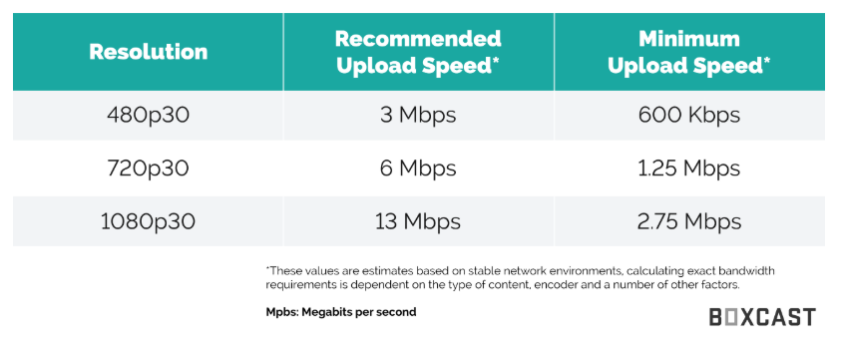

Data Limitation: For sending live videos amount of data is being utilised and day as per data balance we can only use up to maximum of 3GB of data which in case will not be sufficient for live video streaming.

Video Quality: Video quality is also necessary as live stream don't provide a very good quality of video, only few drones provide this feature at a good level such as dji drones but they used Wi-Fi hotspot module.

Technical Support: GSM module is available for Arduino but it can send only SMS. It can also send data to the server obtained by some sensors but live video is not feasible.

There are GSM models which are available for Nvidia jetson but till now Nvidia has not guaranteed that using those modules will provide you GSM support. And they are suggesting Intel Wi-Fi module

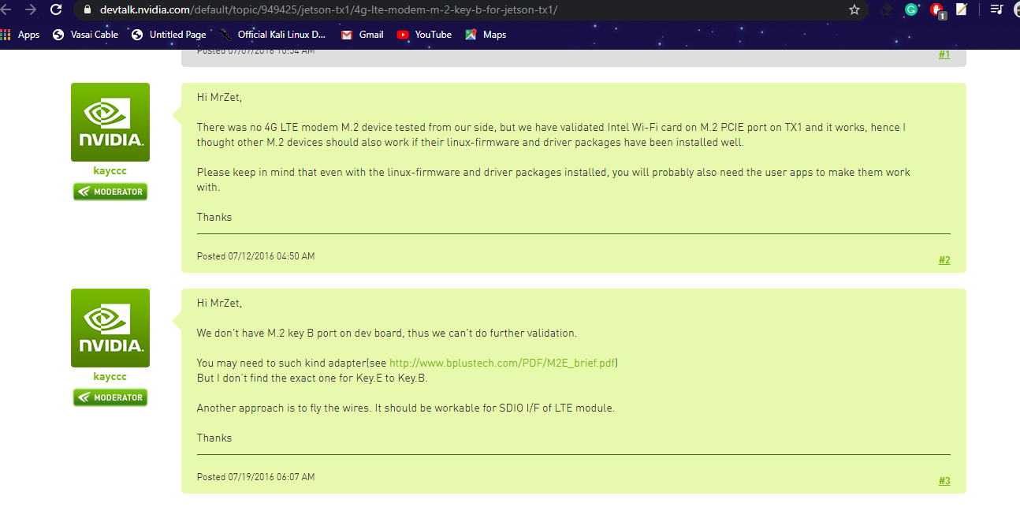

**Limitations of VR Headset:**

Camera Lens Dependant: The VR headset depends on the camera used. If the camera has more than 1 lens, then it will give 3D view in the VR but if only 1 lens is used, it will just act as a theatre screen in front of your eyes.

VR Headset Controlling Drone Support: The DJI drone that supports controlling from the VR headset (head) movements is not available in India. The VR headsets that are available in India are just used for getting the FPV (First Person View) feel of the drone. This FPV feature is not critical in many use cases.

Video Quality: The common sizes of the screens that are available are of 480p. Using a computer, laptop or mobile would be a better option as it will provide us with better screen resolution. The VR headsets that are available in India uses analog transmission as compared to digital transmission, used by DJI VR headset, which has quality issues regarding white lines and other noise factors. Low video quality would perform poorly to see finer details (like small cracks in buildings).

